REAL LIFE AND DISTANCE TIME GRAPHS
Pearson Edexcel - Monday 8 June 2020 - Paper 3 (Calculator) Foundation Tier

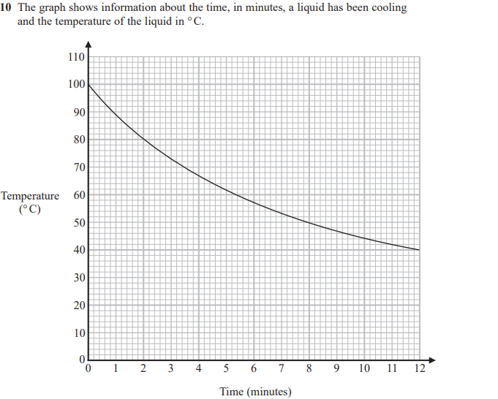
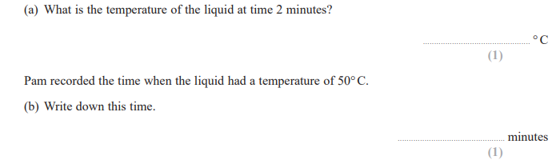
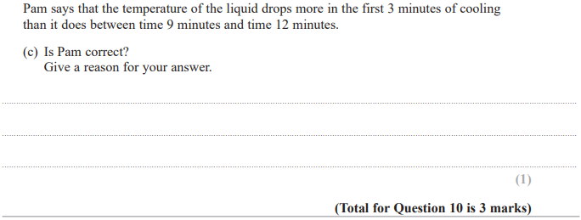

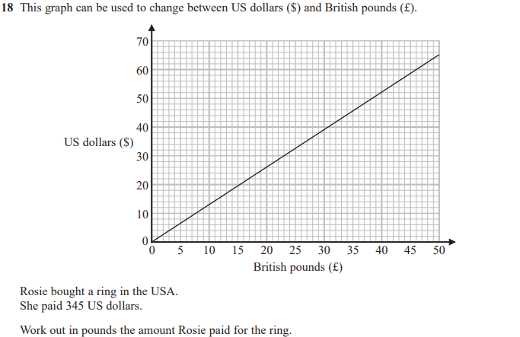

Pearson Edexcel - Tuesday 11 June 2019 - Paper 3 (Calculator) Foundation Tier

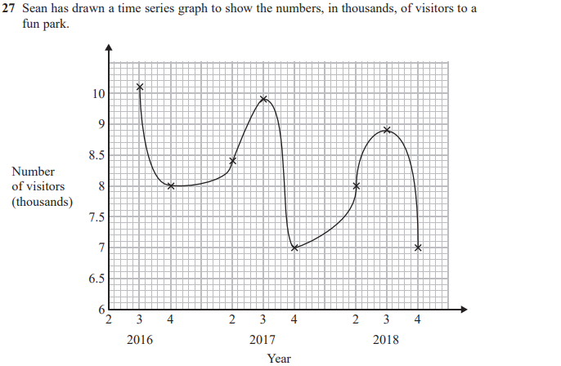
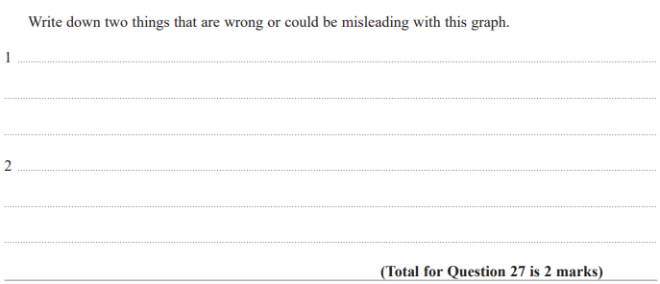

Pearson Edexcel - Tuesday 6 November 2018 - Paper 1 (Non-Calculator) Foundation Tier

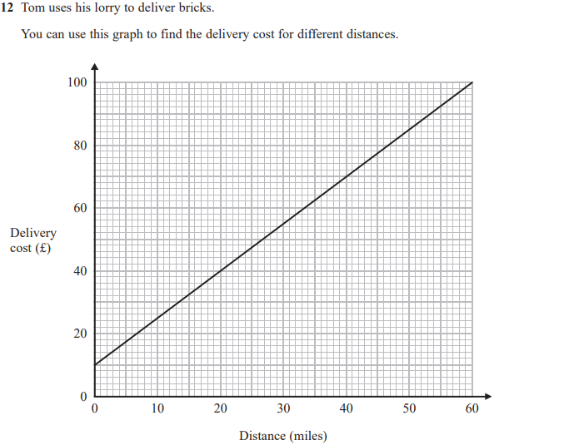

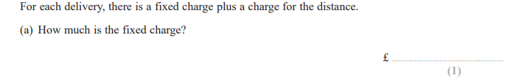
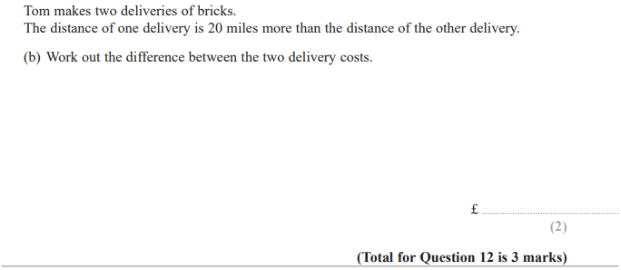

Pearson Edexcel - Monday 6 November 2017 - Paper 2 (Calculator) Foundation Tier

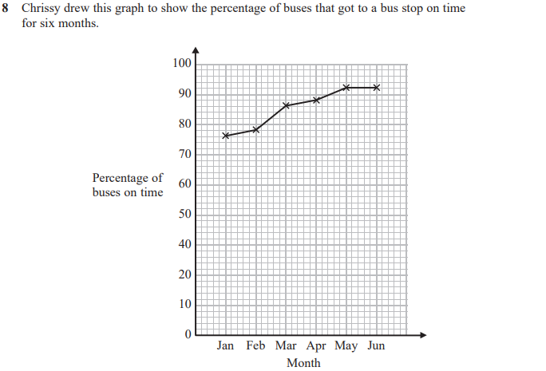
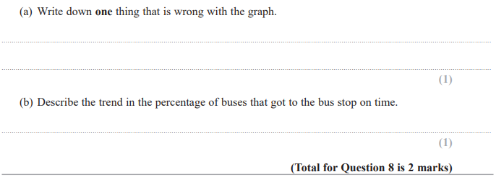

Pearson Edexcel – Specimen 2 - Paper 2 (Calculator) Foundation Tier

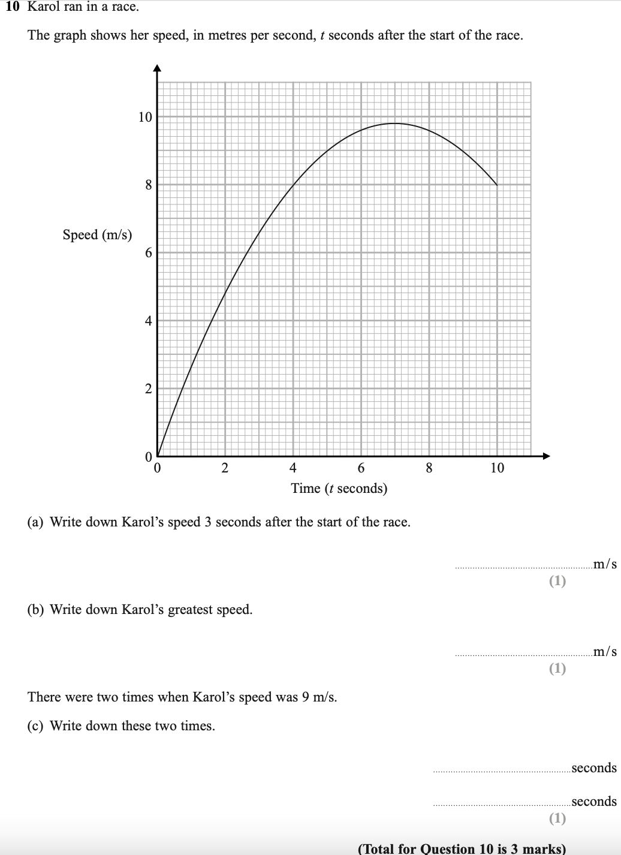

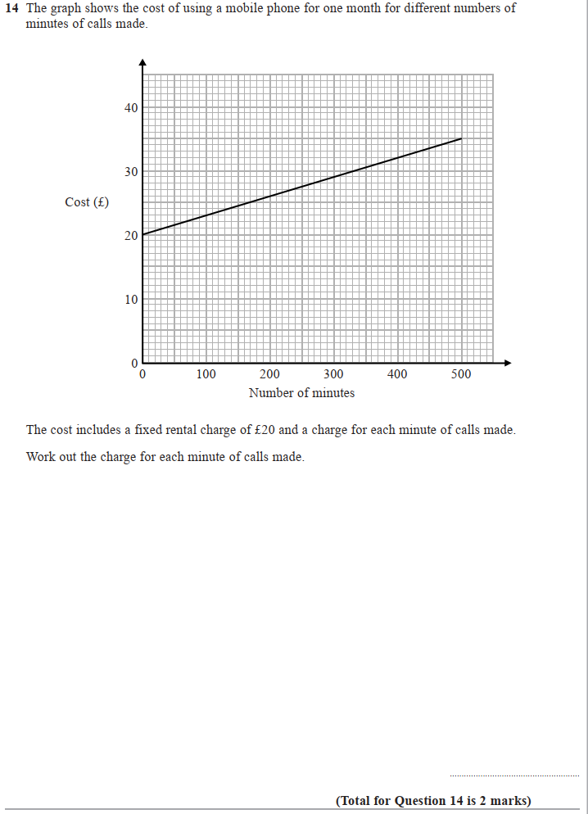

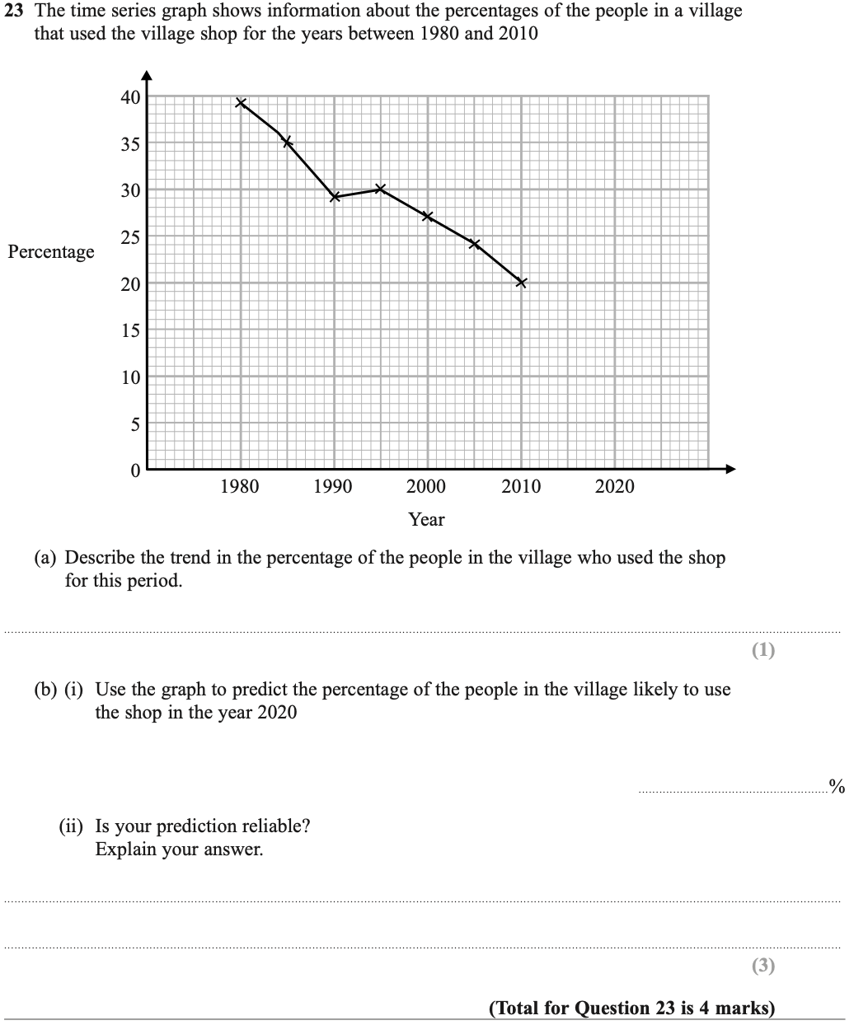

Pearson Edexcel – Specimen 2 - Paper 3 (Calculator) Foundation Tier

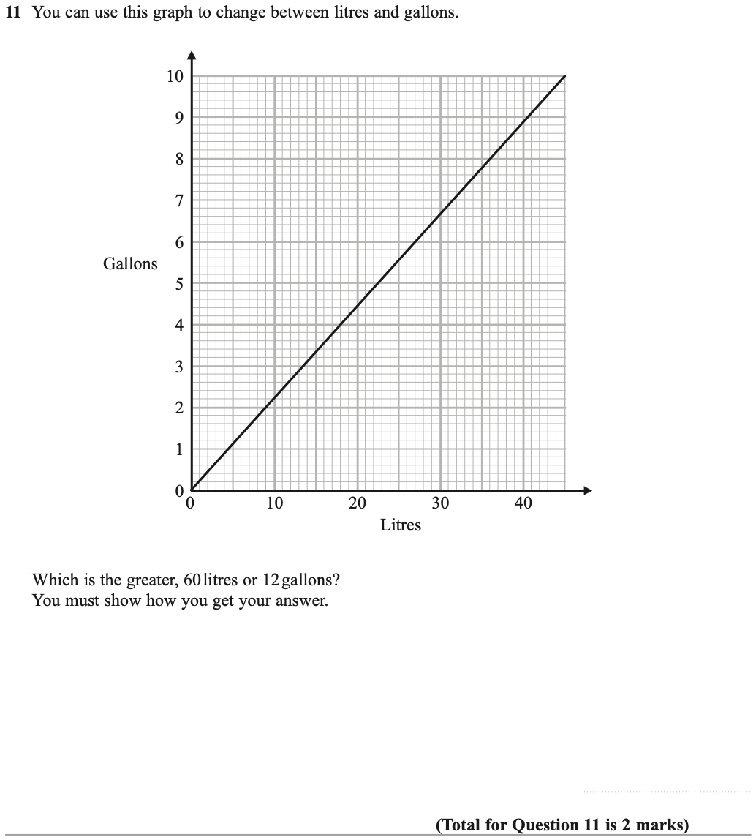

Pearson Edexcel – Specimen 1 - Paper 2 (Calculator) Foundation Tier

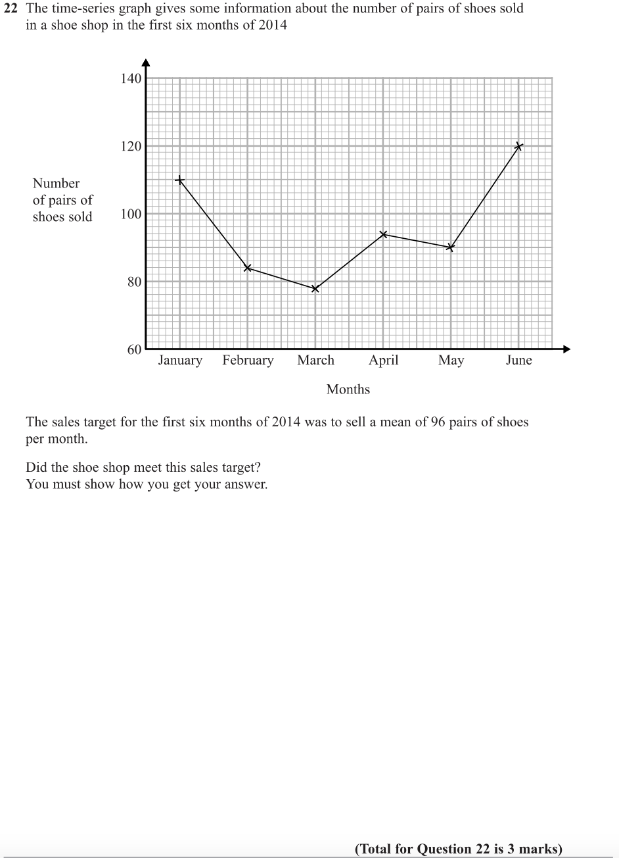

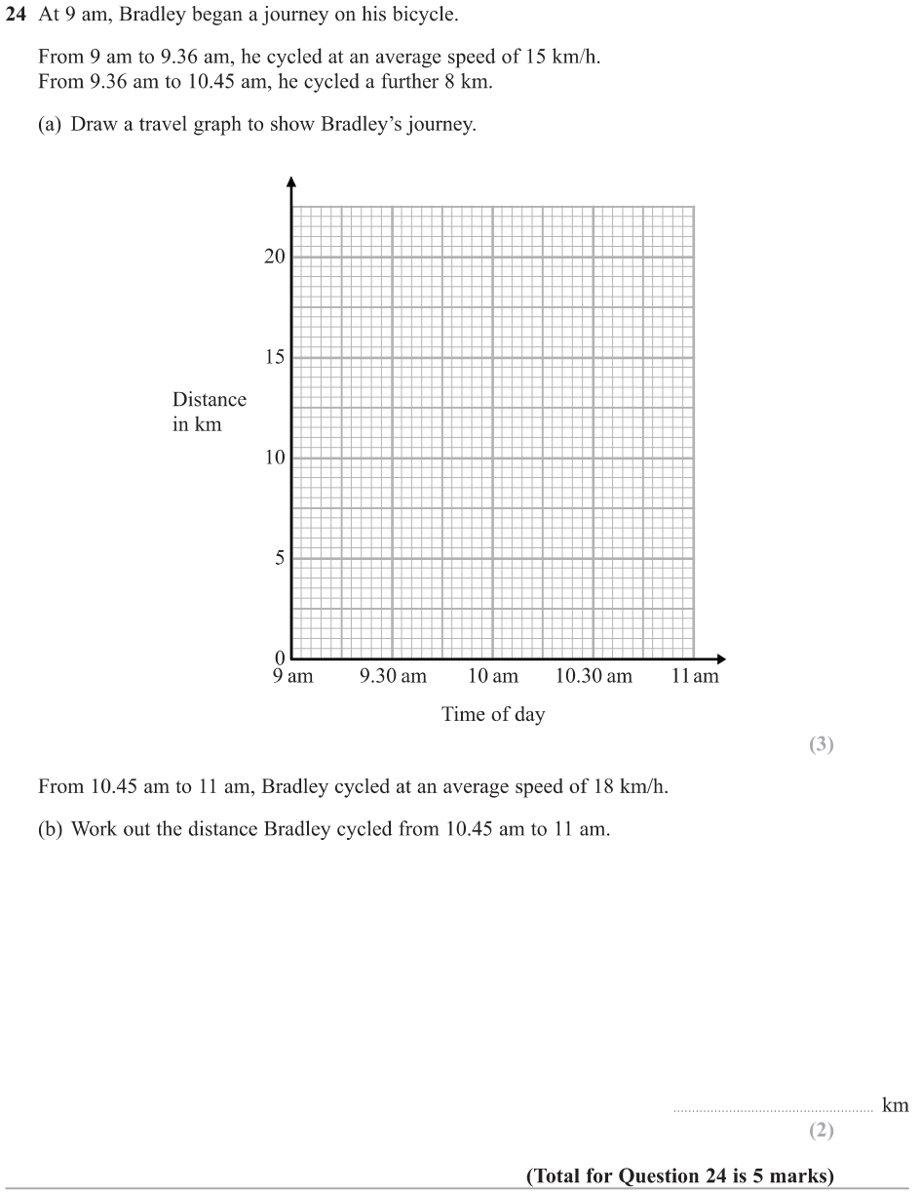

OCR Thursday 6 June 2019 – Morning (Non-Calculator) Foundation Tier
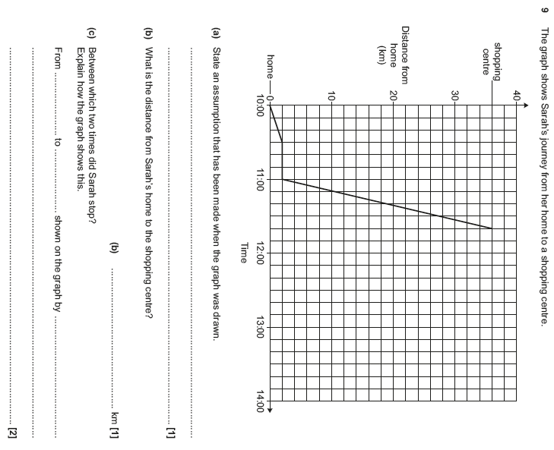

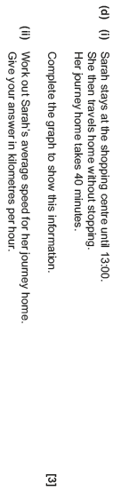

OCR Thursday 7 June 2018 – Morning (Non Calculator) Foundation Tier
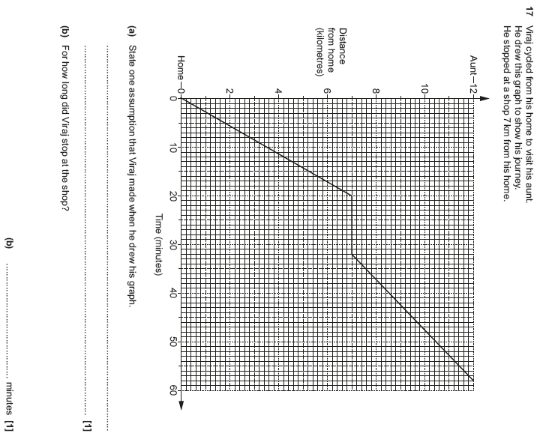

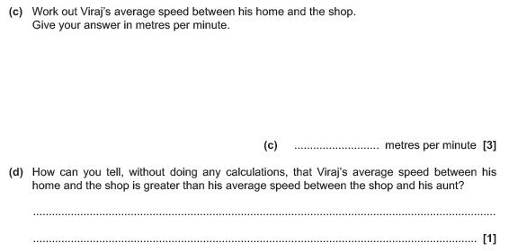

OCR Thursday 2 November 2017– Morning (Calculator) Foundation Tier
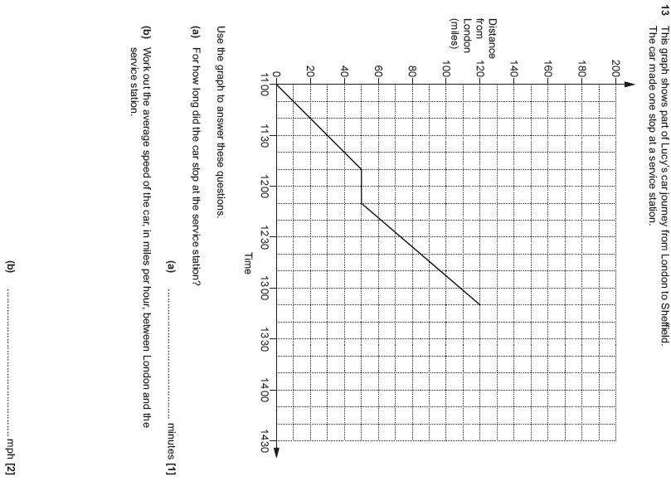

OCR Wednesday 8 November 2017– Morning (Calculator) Foundation Tier

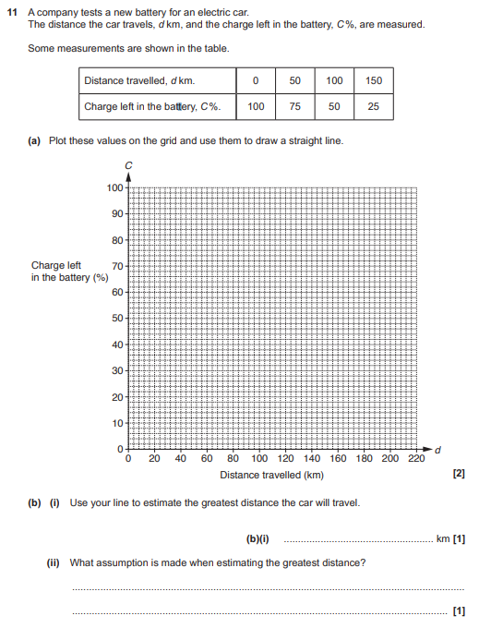

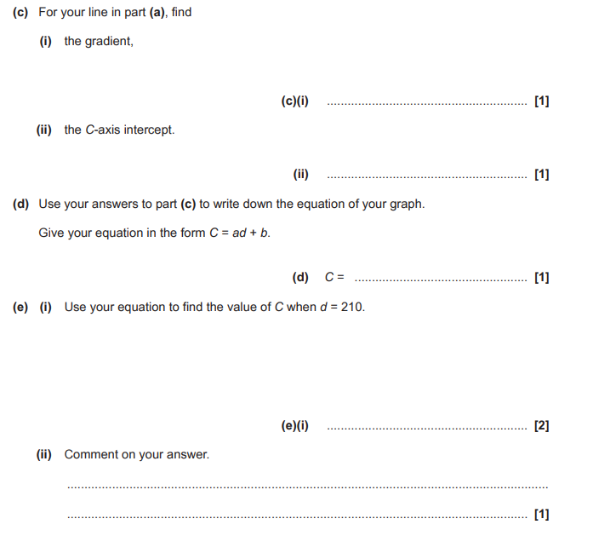

OCR Thursday 8 June 2017 – Morning (Non - Calculator) Foundation Tier

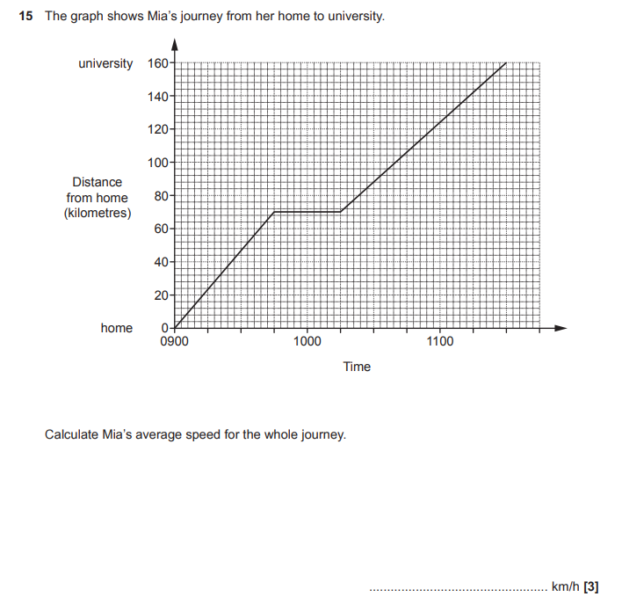

AQA Monday 8 June 2020 – Morning (Calculator) Foundation Tier

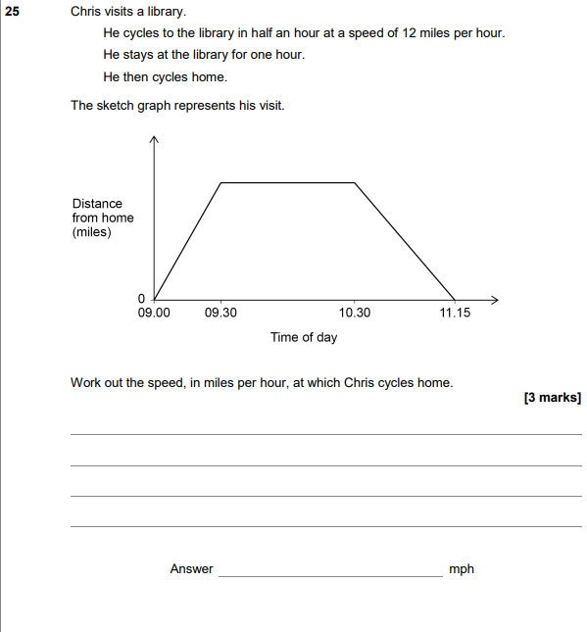

AQA Tuesday 21 May 2019 – Morning (Non-Calculator) Foundation Tier

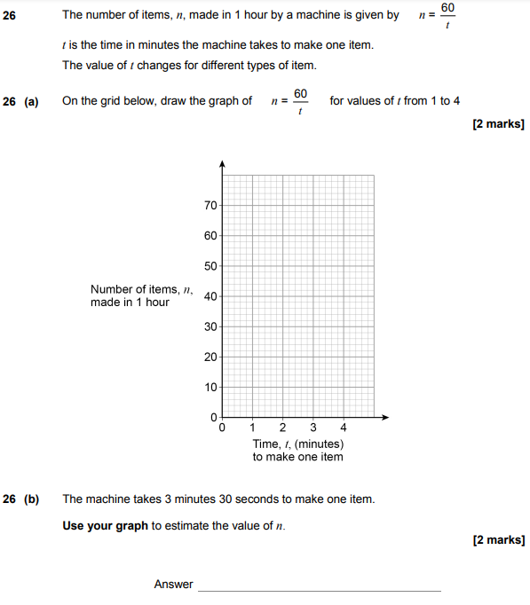

AQA Tuesday 6 November 2018 – Morning (Non-Calculator) Foundation Tier

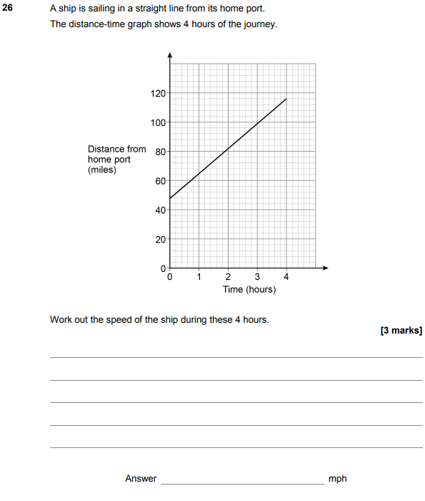

AQA Thursday 2 November 2017 – Morning (Non-Calculator) Foundation Tier

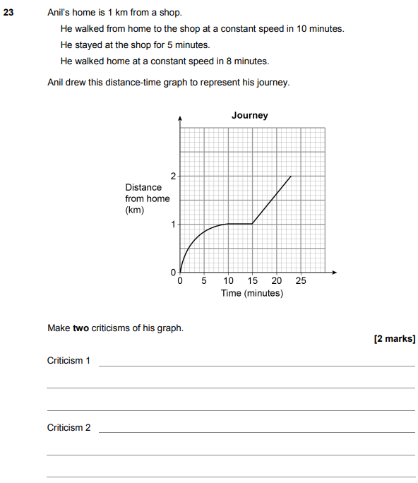

AQA Thursday 8 June 2017– Morning (Calculator) Foundation Tier

